Logic Gates Worksheet
For each logic gate circuit shown below construct and complete their truth tables.
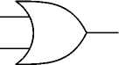
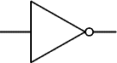
1.
B
A
C
Y

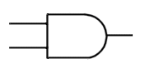
2.
B
A
C
Y
D

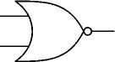
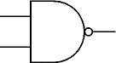
3.
C
B
A
Y
D

